# How to Get Into the Games Industry

In this lesson students learn about video game studios and research a studio of their choice. Students then develop a one-page web presentation to share their findings and reflect on types of roles within game studios.

## Objective

Students will be able to:

* Describe different types of video game studios
* Describe the qualities studios look for in team members
* Explain the design or creative process of a chosen game studio

[Watch](https://video.link/w/NgD5c) the video from Massive Entertainment’s recruiters as they describe different types of careers in the video game industry. Consider the different careers described and the tips for pursuing those roles.

1. How might you be interested in a career producing video games?
2. What roles sound interesting to you and how might you begin planning your path to pursue that career?

# Game Studios

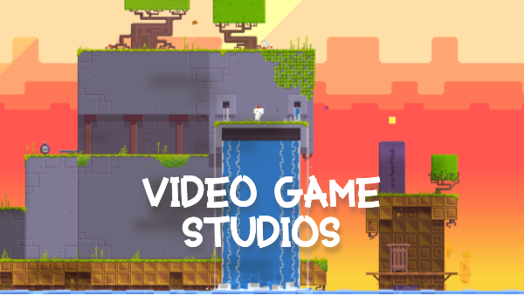

## Overview

Game studios come in all shapes and sizes. Large studios may employ several game designers, artists, level designers, sound engineers, user experience designers, programmers, and other creative professionals on their game production teams. Smaller and indie (independent) studios may only hire up to five employees who serve multiple roles during the game design and development process.

Video game studios may also adopt their own game design philosophies that guide how their games are created and produced. Some game studios even develop their own game engines like Epic Games, creator of the Unreal game engine. These studios typically use their game engine to create their own video games, but sometimes also provide their game engine as a tool to indie developers and smaller studios.

## Objective

In this lesson, you’ll get an insider’s look at what it takes to create a successful game and the roles and positions involved in the studio’s design and development process.

Select a video game studio from the list provided in the Activity Resources section below and use the link as a starting point to learn about the studio. Review other pages on the studio’s website and conduct a web search to gather more information about the company, development teams, and their game design process.

Start thinking about the following questions:

* What’s the size of the studio? Where is it based or located?
* What kinds of roles or positions make up the video game production team? What positions are the studio currently hiring?
* Describe the style of the games the studio develops. What are some of the video games they’ve produced? Are the studio’s games popular or well-known? Does the studio deploy or release their games on a specific platform (mobile, console, PC, web, etc.)?
* Do you believe there’s a correlation between the size of a game production team and the game’s success? Why or why not?
* Describe the studio’s game design or creative process. Did the process use any specific technologies or tools, game mechanics, or level design? If so, how might that make the game innovative, fun, challenging, or successful?

## Activity Resources

These links will get you started, but be sure to review other pages within the studio’s website for more information.

* Ubisoft Games - How We Make Games  
  <https://www.ubisoft.com/en-us/company/how-we-make-games/creative-process>
* Blizzard Entertainment  
  <https://careers.blizzard.com/global/en>
* Hipster Whale  
  <https://www.hipsterwhale.com/careers>
* Epic Games  
  <https://www.epicgames.com/site/en-US/careers>
* Nintendo  
  <https://careers.nintendo.com/>
* BANDAI NAMCO Entertainment  
  <https://www.bandainamcoent.com/careers>